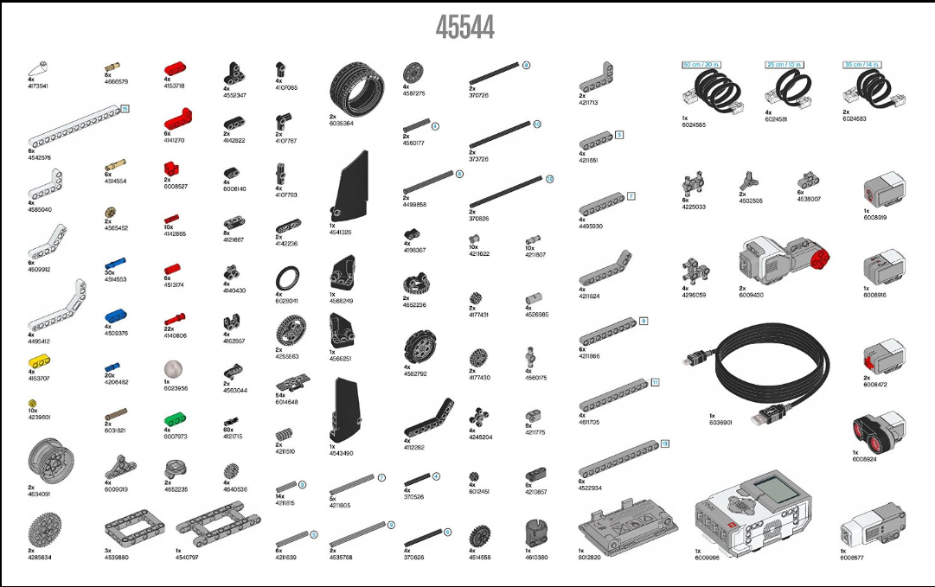
Name(S): __________________________________________________ Period: ______________ Team Number: __________ KIT NUMBER: _________
___________________________________________________
COMPLETE KIT: ______________ Why were you able to or not able to complete your kit? ______________________________________________________ ___________________________________________________________________________________________________________________________________

