Name: _______________________________________ Period: ________________
EV3: Overview Lesson 1
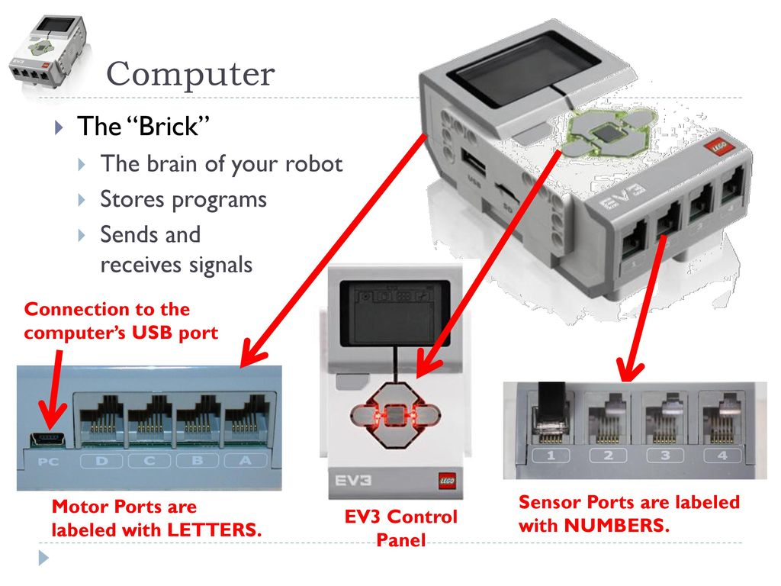
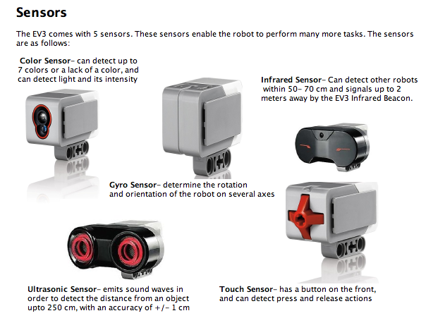
- TRUE or FALSE Motor ports are labeled with letters.

- TRUE or FALSE Sensor ports are labeled with letters.

- The “Brick” is the _________ of your robot.

- Would you consider the “brick” hardware or software? Explain your reasoning.

- Describe what a gyro sensor allows the robot to do.

- Which two sensors can detect distance?

- Which sensor acts as a “bumper”?

- The ________ sensor can detect up to 7 colors or a lack of color, and light intensity.
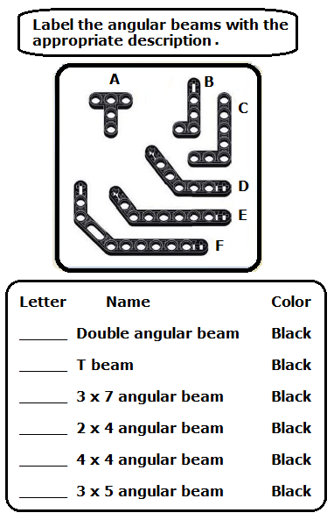
- Which comes first in the robotic classroom? TEST, PROGRAM, BUILD: _______________ Explain your answer.

- Complete the chart to the left. Did you complete it? Why was it hard or easy for you to complete?

- Have you ever built a robot before? What types of robots have you built and what did you learn?

- How will you help this classroom stay organized?

- What are the 3 or more things that you must do in the last five minutes of class?

- LEGO MINDSTORMS is a programmable robotics construction series that gives you the power to build and program your own LEGO robots. The LEGO MINDSTORMS EV3 set includes everything you need – motors, sensors, programmable brick (P-brick), cables, remote control and TECHNIC elements – to create robots that walk, talk, move and do whatever you want them to. Building your own robot and programing it through the intuitive software program, the P-Brick or your smart device allows one to truly create and command it!

What 3 devices that have you have seen in the room or outside of the classroom/online/from a friend that you would like to design?

- Did you know?? You can download the building instructions for TRACK3R, SPIK3R, R3PTAR, GRIPP3R and EV3RSTORM from www.LEGO.com/mindstorms. You can also download them as 3D building instructions as part of our EV3 3D Builder app which is free to download for iOS and Android tablet devices from App Store and Google Play.
What two places can you attain 3D building instructions?

