Name: ______________________________________ Period: ______________
NXT Overview Lesson 1
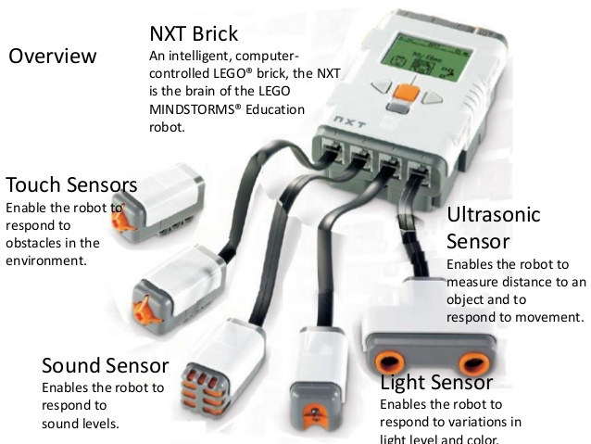
- Compare two sensors above and describe how they are different.

- Analyze two other sensors and describe a scenario in how they both could be utilized for a particular robot.

- Name the 12 parts with a labeled sketch from the REPEATING video https://www.emaze.com/@ALRWIQLR

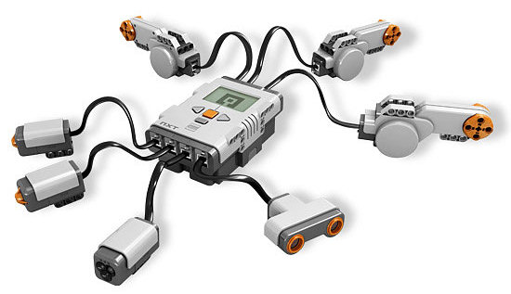
- How many objects from this picture above were not on the previous page? What do believe is their function?

- What would you propose as the difference between software and hardware? (Hint: Think about the “BRICK” and sensors and where they might fit into this role)

- Another term used in robotics is firmware. Based on the previous two terms, what might firmware be defined as in terms of robotics? (Hint: Think about the terms “BRICK”, sensors, and written programs and where they might fit into this term)

