NAME(S): __________________________________________________________________________________________ Pd: ___________
VEX IQ SUPER KIT CHECKLIST
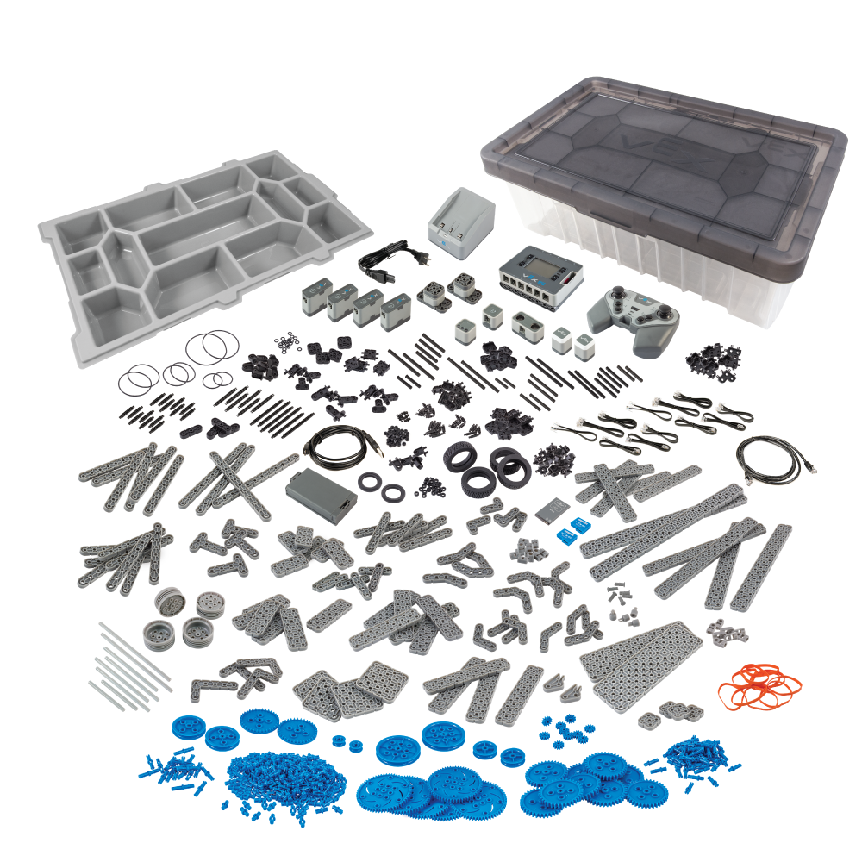

- Identify each part using the VEX IQ PARTS MAP to complete the checklist on the back of this document.

- Some items may be in other boxes or excess parts bins. You may have to check them out and collaborate with your classmates so that all can complete their sets. Good luck and work with respect of others!

Please make sure to check off each part section on the list below. I understand if that takes more than one class period to achieve.
100% completed inventory: ______________ VEX SET NUMBER: ____________
